SpendWise

Project Title
SpendWise – A Simple Backend Learning Project using Node.js, Express, MongoDB, and JWT

Team Details
- ​Team ID: SWTID-2026-8291
- ​Team Size: 4
​
Team Members
- DEEPIKA R (Team Leader)
- ​SIVANI K
- ​BOOMA V
- ​PRIYADHARSHINI A S

Project Overview
SpendWise is a backend application developed to demonstrate how to build secure REST APIs using Node.js, Express.js, MongoDB, and JWT authentication. The project allows users to perform basic CRUD operations on transaction records while ensuring secure access through authentication. MongoDB is used for storing data and Mongoose is used to manage database interactions. The application follows a simple backend architecture to help beginners understand how real-world backend systems work.
Key Objectives:
- Implement secure authentication using JWT
- Perform CRUD operations on transaction data
- Integrate MongoDB using Mongoose
- Protect API routes using middleware
Target Users:
- Beginner backend developers
- Students learning Node.js and Express
- Freshers preparing for technical interviews

Project Instruction
SpendWise is a backend-only project developed using Node.js and Express.js to demonstrate REST API development and database integration with MongoDB.
Quick Start:
npm init
npm install
npm run dev

Steps to Create the Project:
● Choose or create a folder for the backend project.
● Open the terminal and navigate to the project directory.
● Initialize the Node.js project using npm init.
● Install the required packages such as express, mongoose, jsonwebtoken, bcrypt, cors, and dotenv.
● Create the necessary folders including models, routes, controllers, middleware, and config.
● Configure the MongoDB database connection.
● Start the server using npm run dev.
● Test the APIs using Postman or Thunder Client at http://localhost:5000.

Pre-requisites:
Software Requirements
Software | Purpose
Node.js | JavaScript runtime for backend
MongoDB | NoSQL database for data storage
npm | Package manager
Git | Version control system
Code Editor | VS Code or similar

Knowledge Requirements
- JavaScript ES6+
- Node.js and Express.js
- MongoDB and Mongoose
- JWT authentication
- Basic REST API concepts
- Git basics

Thumbnail for Project
- A simple backend project thumbnail representing:
Node.js + Express + MongoDB + JWT + CRUD APIs

Project Architecture Image
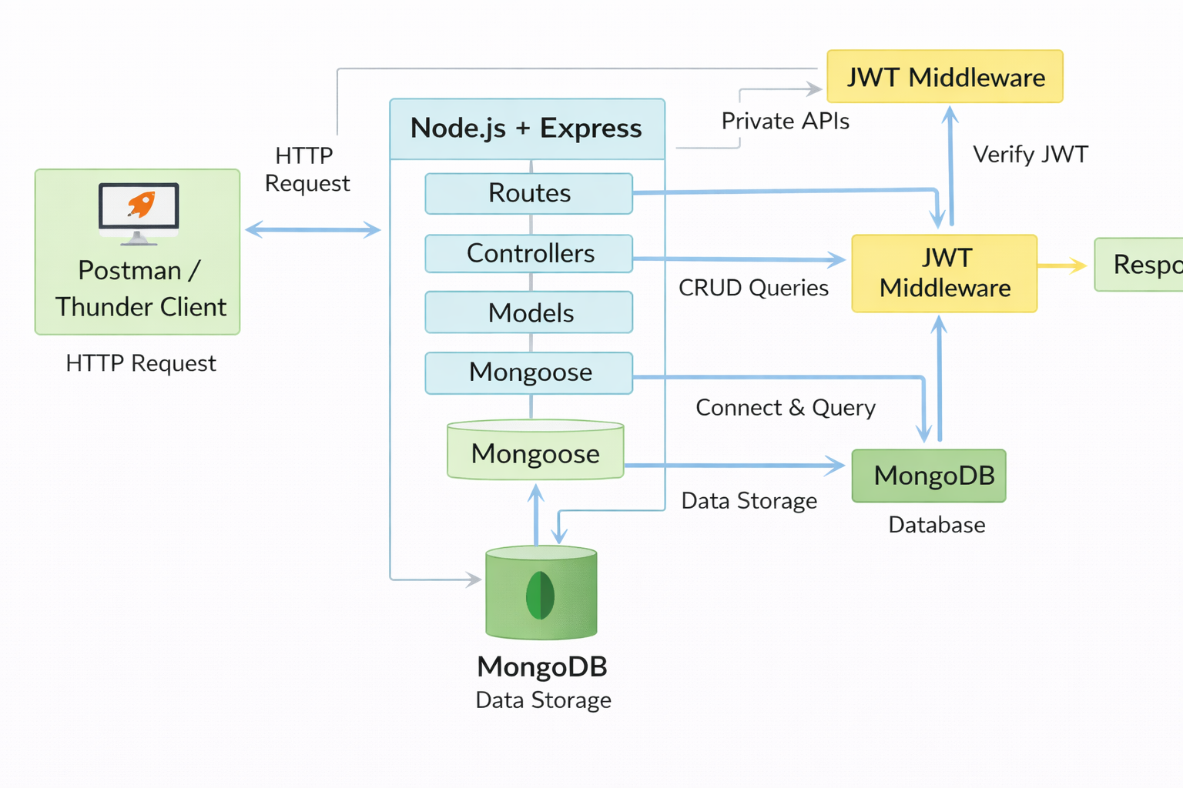

Technical Architecture

Backend Architecture (Node.js + Express)
● Controllers: Handle the main business logic such as user authentication and CRUD operations.
● Models: Define Mongoose schemas for the User and Transaction collections.
● Routes: Provide API endpoints for authentication and transaction management.
● Middleware: Used for JWT verification and protecting secured API routes.
● Configuration: Manages database connection and environment variables.
Database Architecture (MongoDB)
● Users Collection:
_id, name, email, password (hashed), createdAt
● Transactions Collection:
_id, userId (reference), title/description, amount/value, createdAt
● Relationship:
Multiple transactions belong to a single user (One-to-Many relationship).

ER Diagram
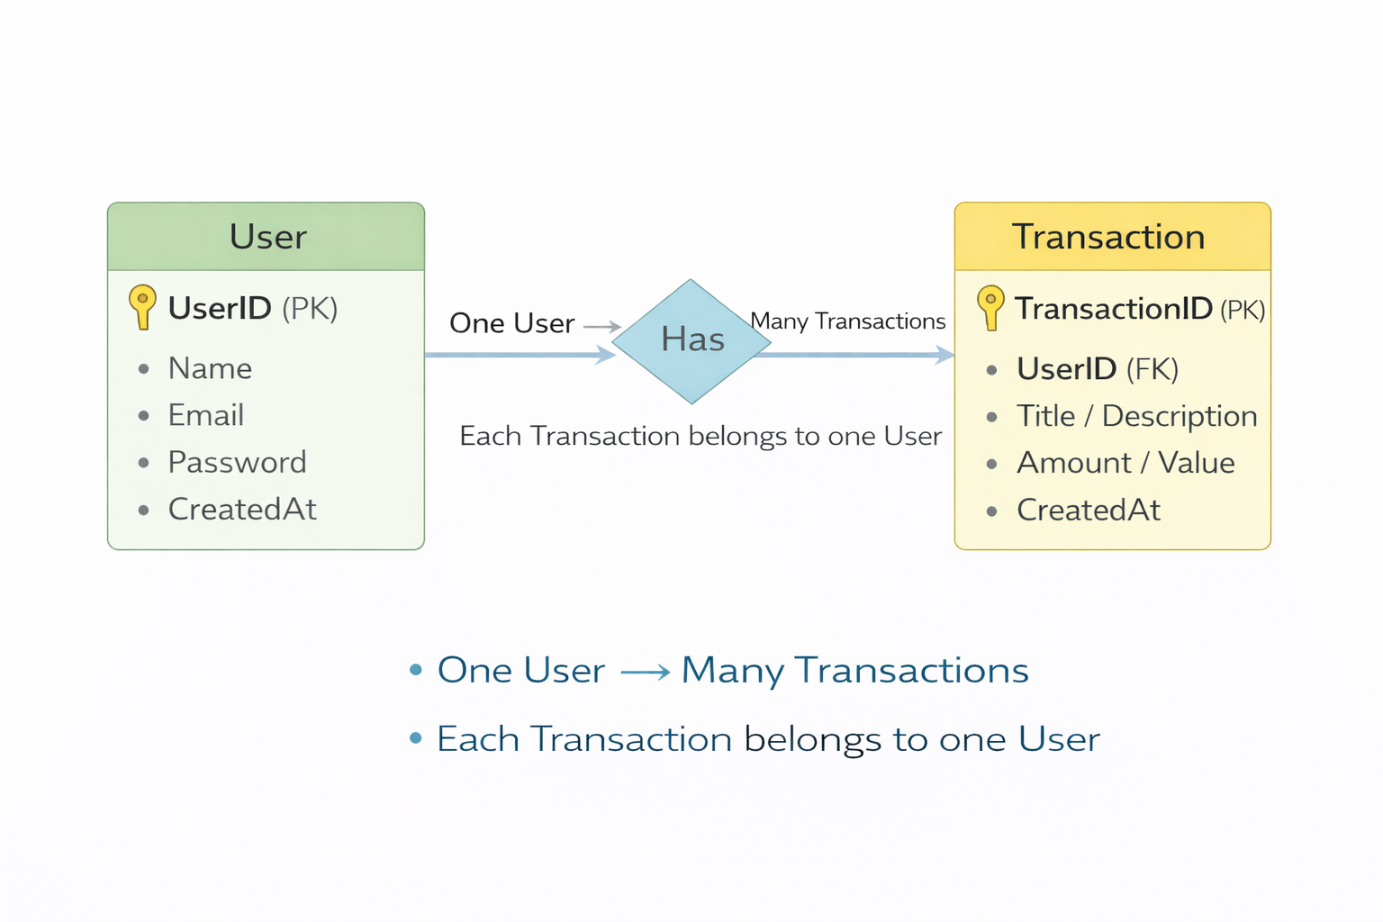

Features

# | Feature | Description
1 | User Authentication | JWT-based registration and login
2 | CRUD Operations | Create, Read, Update, Delete transactions
3 | Protected Routes | Secure APIs using JWT middleware
4 | MongoDB Integration | Store and fetch data using Mongoose

Roles and Responsibilities
Student / Developer:
- Write backend code
- Create APIs
- Test APIs using Postman/Thunder Client
- Push code to GitHub
System (Backend):
- Authenticate users using JWT
- Handle CRUD operations
- Store and fetch data from MongoDB
- Protect private routes

Users Flow:
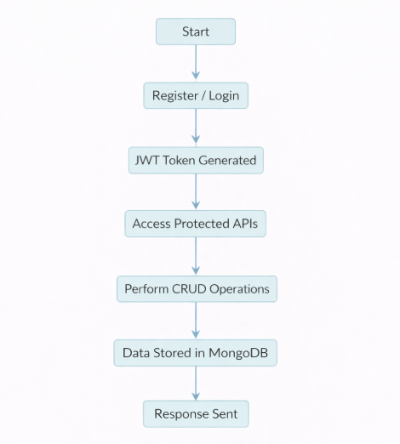

PROJECT SETUP AND CONFIGURATION

Folder Structure
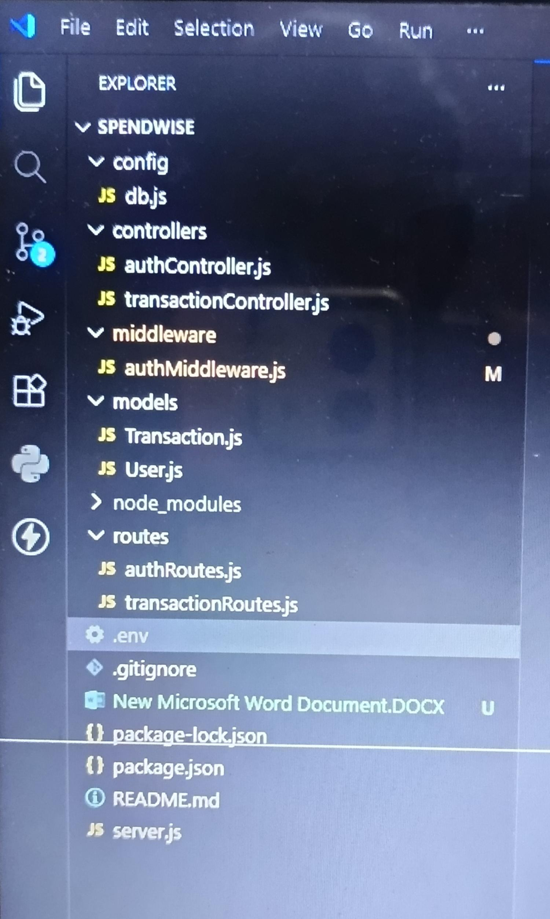

Project Setup
1. Install required tools:
- Node.js
- MongoDB
2. Create project folders:
- server folders (models, routes, controllers, middleware, config)

3. Install Backend Packages:
- Express
- Mongoose
- Cors
- Jsonwebtoken
- Bcrypt
- Dotenv

BACKEND DEVELOPMENT
- Setup Express server
- Create server.js file
- Create .env file and define PORT and DB URL
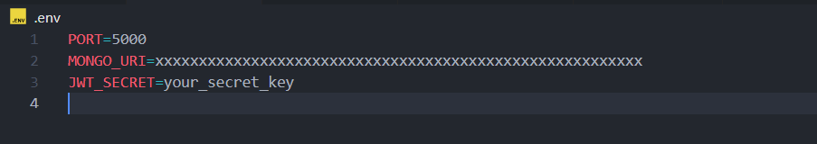
- Configure middleware (cors, express.json)
- User Authentication:
  - Create Register and Login routes
  - Generate JWT token
  - Protect routes using middleware

- Define API Routes:
  - Auth routes
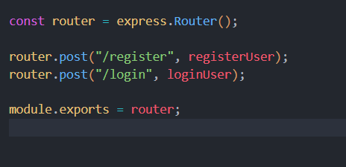
  - Transaction CRUD routes

- Implement Data Models:

  - User schema
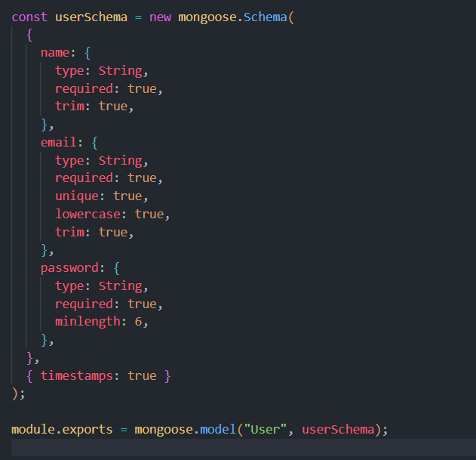

  - Transaction schema
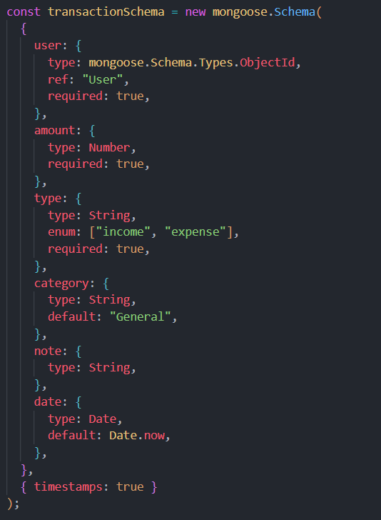

- Implement CRUD operations
- Add basic error handling

DATABASE DEVELOPMENT

Configure MongoDB
- Use MongoDB Atlas or local MongoDB
- Store connection URL in .env file
- Connect using Mongoose

Create Database Connection
- Create a config file for DB connection
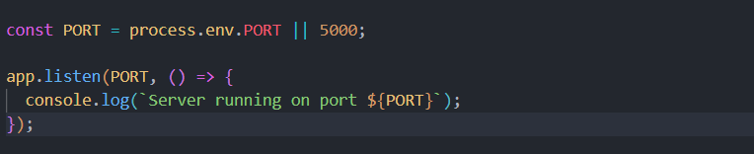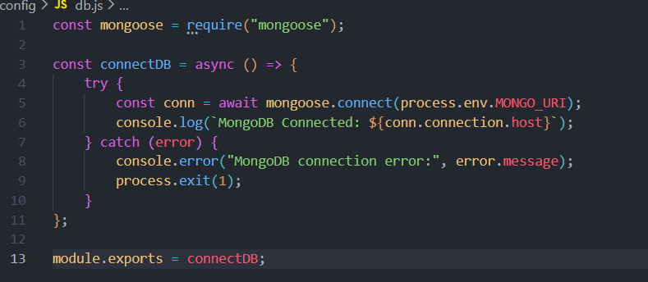
- Use mongoose.connect()
- Handle success and error cases

Create Schema and Models

User Model:
- Name
- email
- password

Data / Transaction Model:
- userId
- title / description
- amount / value
- timestamps

PROJECT EXECUTION

Project Execution Steps:
- Start MongoDB
- Run backend server
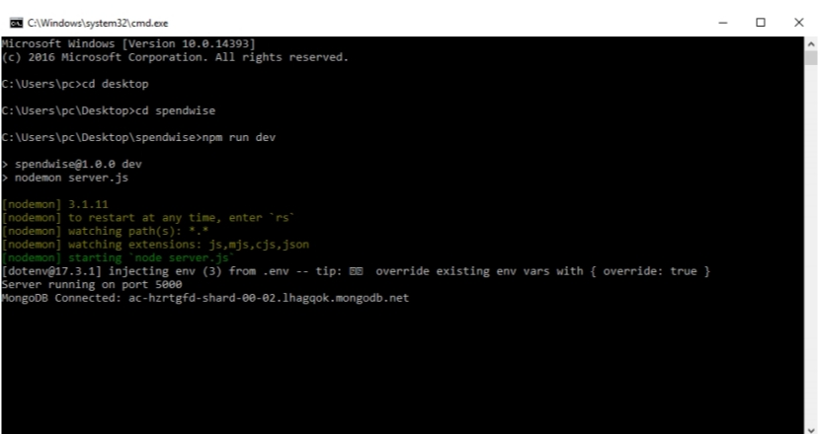

- Test Register API
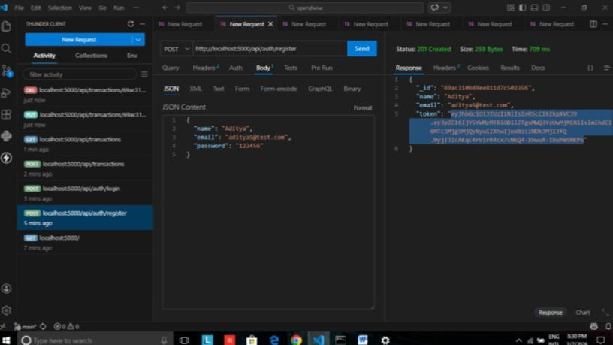

- Test Login API
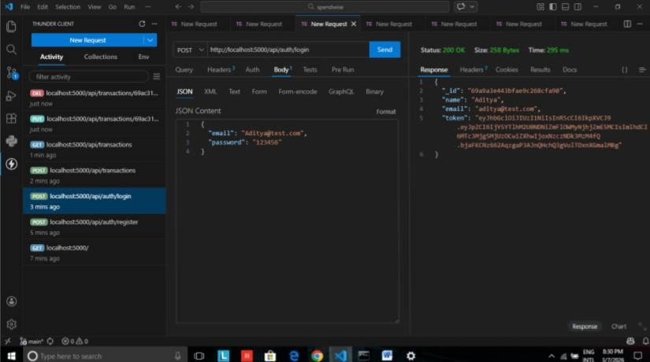

- Copy JWT token
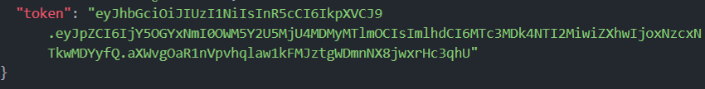
- Use token to access protected CRUD APIs
- Perform Create, Read, Update, Delete operations

OUTPUT SCREENSHOT

- Register API
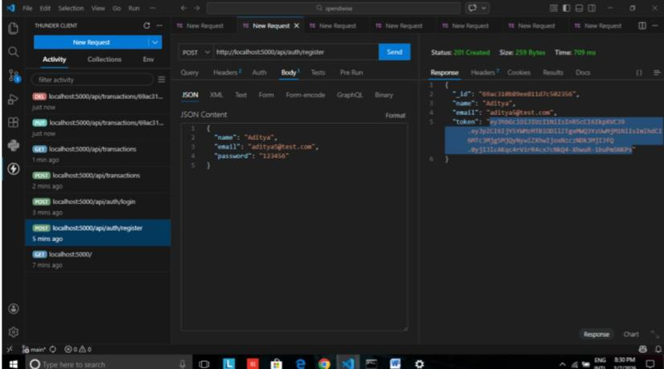

- Login API
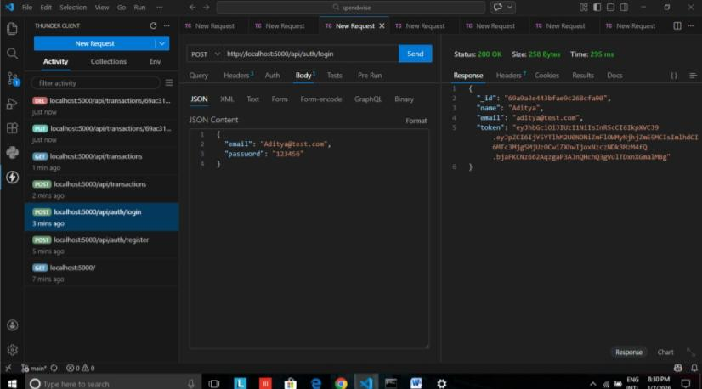

- Create Transaction
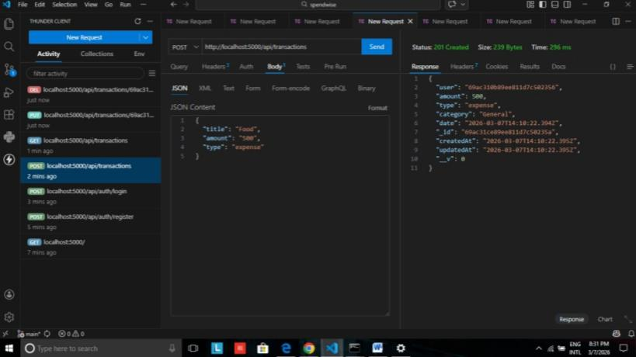

- Get information
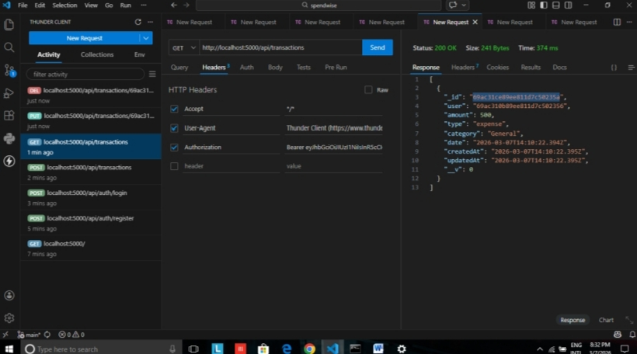

- Update API
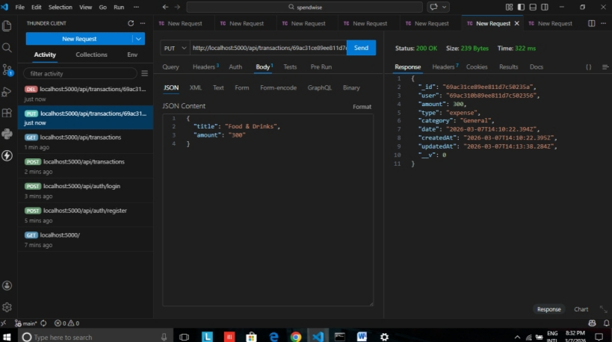

- Delete API
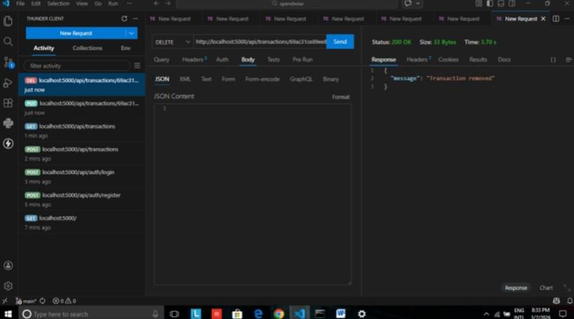

Project Demo Video
https://drive.google.com/file/d/1oEAnmz7XHz_qnuLkP1Mes-Sqb1RyMd_1/view?usp=drivesdk

